

**LAB ASSIGNMENT 3**

**SUBMITTED BY:** Kulsoom Khurshid

**REGISTRATION #:** SP20-BCS-044

**COURSE:** Operating System

**SUBMITTED TO:** MA’AM ZAHIDA WALIYAT

**QUESTION 1**

**Part1**

**Write a program in C++ (child.cpp) that declares two integer type arrays of size 30. At runtime, the program asks the user to enter values in theses arrays (it is up-to the user how many values he/she enters). Once the arrays are populated, child.cpp finds how many values are same in both arrays. Write another program in C++ (main.cpp) that creates a child process and replaces its code with child.cpp (executable) and waits until child completes its execution. The child process shares the number of same values with parent process and parent process displays it.**

CODE:

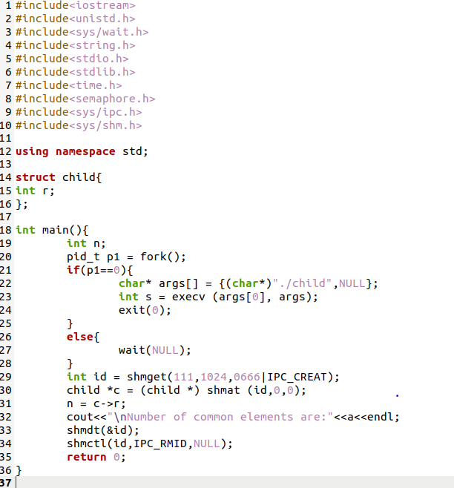Child.cpp: Main.cpp

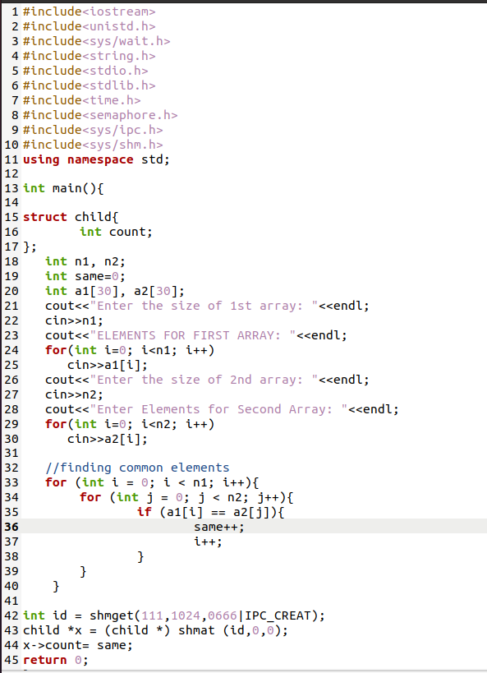  
  
COMMANDS AND OUTPUT:

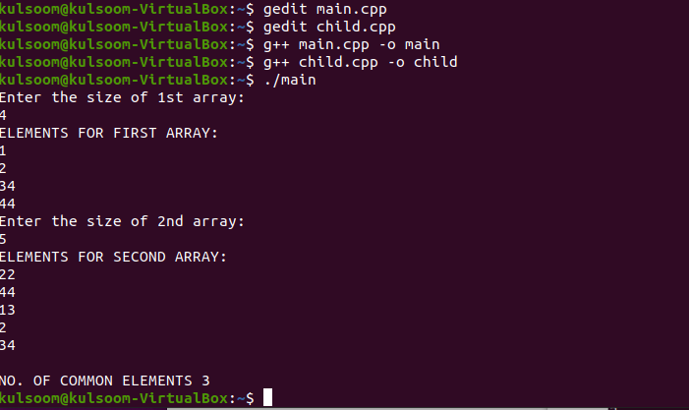

**Part2**

Write a multi-threaded program that implements the same functionality as stated in Part-1 i.e. a thread creates arrays and find the number of same values in these arrays. Then the number of same values is shared with the main thread. The main thread then displays it.

CODE:

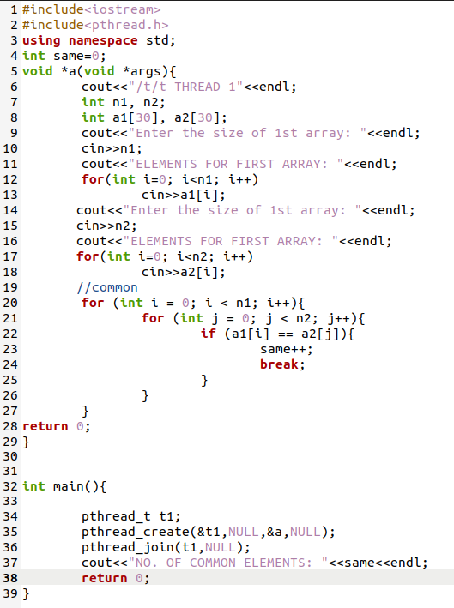  
COMMANDS AND OUTPUT:

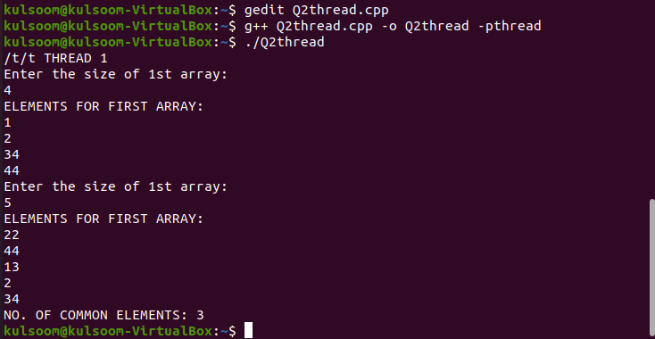

**QUESTION 2:**

**Part1**

Write a C++ program that creates an array of size 30 of type integer. During execution, the program should ask the user to provide input. When the input is completed, the program should count how many prime numbers are entered by the user. Calculate the total time required by the system to execute the program.

CODE:

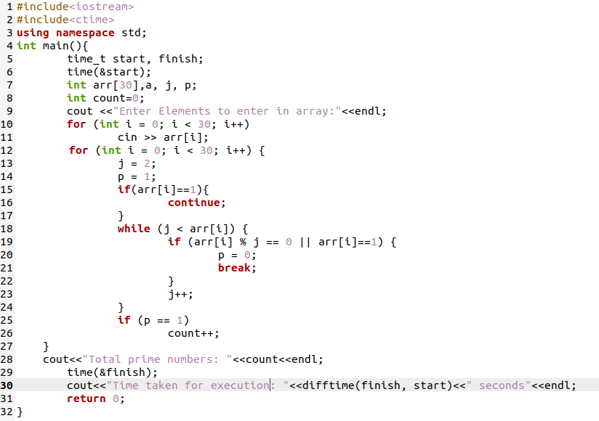  
COMMANDS AND OUTPUT:

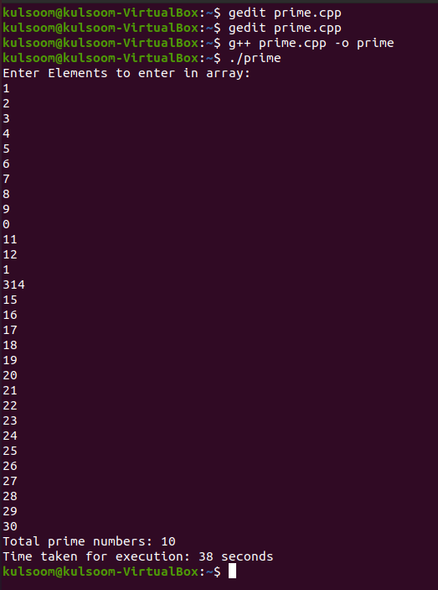

**Part2**

Convert the program given in Part 1 into multi-process application. The main parent program should take the input while the two children processes should calculate the number of prime numbers (from 15 array elements each) and share the number of prime numbers with parent process. The parent process should display the total number of prime numbers. Calculate the total time required by the system to execute the program.

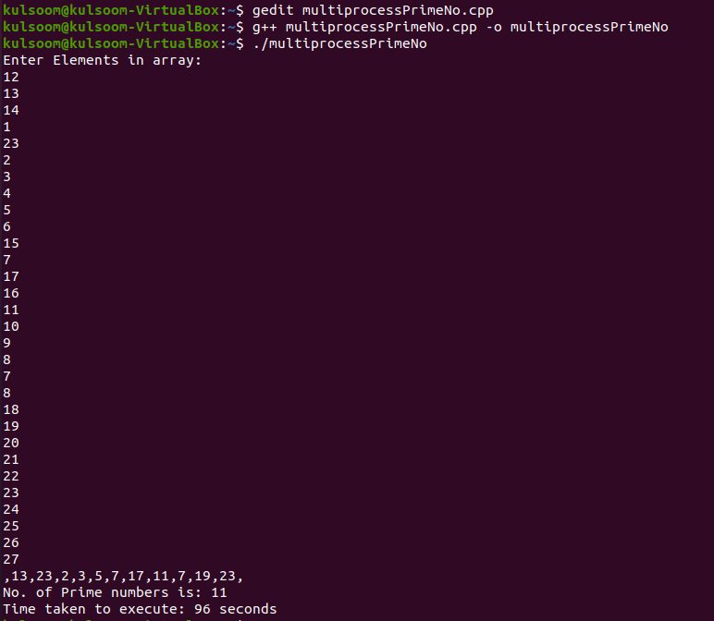COMMANDS AND OUTPUT:

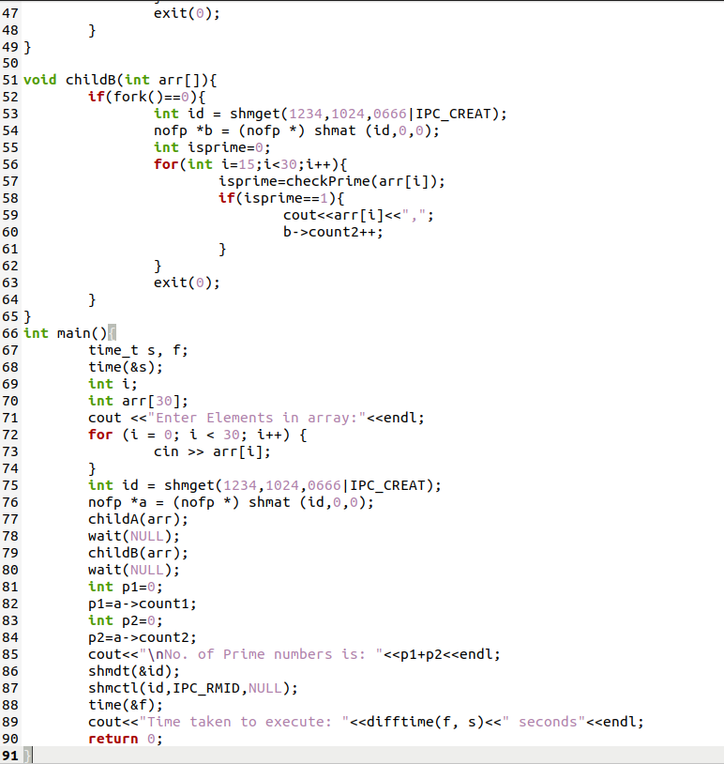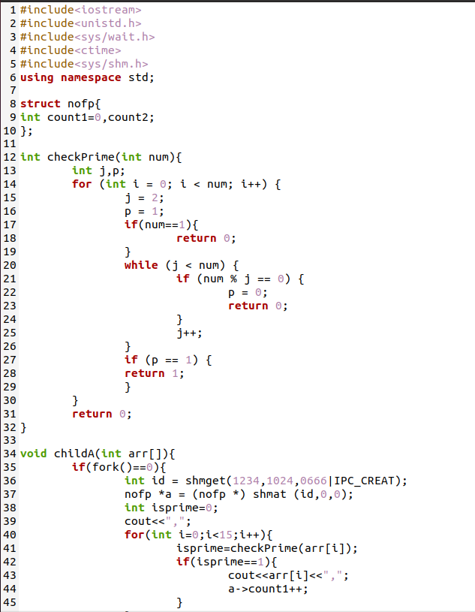CODE:

**Part3**

Convert the program given in Part 1 into multi-threaded application. The main thread should take the input from user. Create two more threads that calculate the number of prime numbers (from 15 array elements each) and share the number of prime numbers with main thread. The main thread should display the total number of prime numbers. Calculate the total time required by the system to execute the program.

CODE:

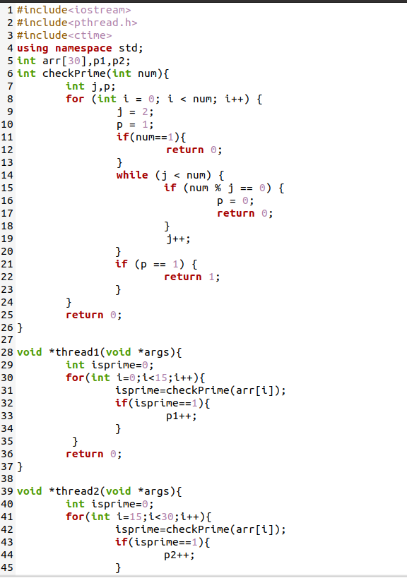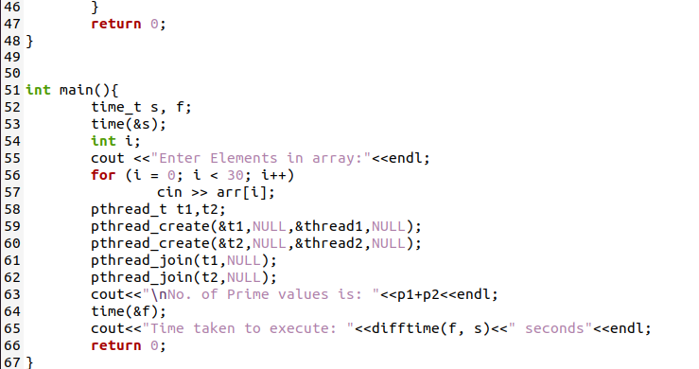  
COMMANDS AND OUTPUT: